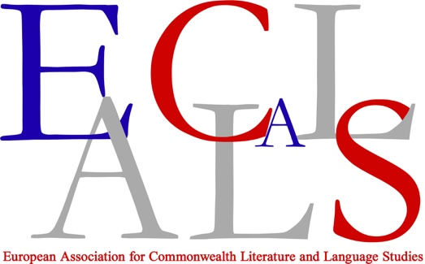

Report of the Chair, AGM 2022
Radhika Mohanram

2019-2020

17th triennial conference at the Cardiff University, Wales, May 2020

Cardiff University made a successful bid for the 17th triennial conference in May 2020 to coincide with the Hay Festival. A CFP on the topic of Transcultural Mo(ve)ments: Memories, Writings, Embodiments was prepared and approved by the Board. The CFP resulted in, 135 approved proposals and arrangements were made for a face-to-face conference including developing a conference website. By late March the country was in lockdown due to Covid and Cardiff University cancelled all campus conferences. With the uncertainty caused by the pandemic no concrete decisions of any sort regarding a future conference could be made.

Dec 2020-June 2021
In December 2020, Cardiff was once more approached to host the cancelled conference and, after enquiries, it was decided that it would be held online because of the continuing uncertainty caused by the pandemic. By this time, Cardiff University had a well-developed platform for online conferences; however, the take-up for the online conference was fewer than for the face-to-face version. In the end, there were 98 papers offered by participants as well as 5 plenary addresses during the 3 day conference. The plenary addresses were as follows:
1) Kirstie Bohata of University of Swansea (“‘Wealish‘: Transcultural Experiments in Plurilingual Writing“);
2) John MacLeod, University of Leeds (“Bloody Postcolonialism”)
3) Ruth Vanita, University of Montana (““Forced Apart: how Legal Discrimination against LGBT People Affects Transcultural Movement”)
4) Michael Bucknor, The University of West Indies ("Transcultural Violence, Intimate Embodiments: Marlon James's Queer Poetics")
5) The final plenary was the Anna Rutherford Memorial Lecture delivered by Ann Collett, University of Wollongong (“A Braided Biography of Australian Poet Judith Wright and Canadian Painter Emily Carr: The Challenge and Value of Transcultural Research and Collaborative Writing”).

Wasafiri magazine which focusses on International Contemporary Writing presented a wonderful round-table event of discussions with creative writers at the conference.

The Board also decided to waive registration fees for the conference as expenses would not be incurred for bringing in the plenary speakers or by granting bursaries to attendees. This was a popular move that ensured maximum participation at the conference.

At the AGM meeting of EACLALS held at the conference, a new Board to hold office between May 2021 and March 2023 was elected:

Radhika Mohanram (Chair)
Isabel Carrera (Previous Chair)
Melissa Kennedy (Secretary)
Miasol Llarina Eguibar Holgado (Treasurer)
Devika Karnad (Student Representative)
Ala’a Al Ghamdi (Webmaster and Social Media Co-ordinator)

It was decided that the 18th Triennial conference would take place in Paris, France between 27th-31st March 2023. It was also decided that the headquarters (or official registration) of the Association would stay in Austria and that the bank account would also remain in the same bank, with the new Treasurer handling the account through digital means. This made logical sense as to transfer accounts to the UK and to convert to pound sterling was unnecessary because the accounts would revert back to France and the Euro in 2023.

August and September 2022

The plenary addresses from the Cardiff conference as well as a number of sessions which had been recorded were made available to all members on the conference website for two months.

November 2021-March 2022

The EACLALS website which was old was re-developed to make it more intuitive and user-friendly (Eaclals.com).

April 2022- June 2022

At Board meetings it was decided that to ensure the longevity of the Association more attention had to be focused on post-graduate students. Bi-monthly online events will be held on topics which are of interest to post-graduates. The first event held in April 2022 was a lecture by Dr Michela Borzaga who gave a talk on "Developing Thought-systems and Voice in Academia: A First-gen Testimony.” This lecture was well-received and in June 2022, two presentations were made in the Work-in-Progress series. They were by Khadija Koroma from the University of Leicester-UK who spoke of her PhD on the Heinemann African series fiction and Bianca Cherechés from the University of Zaragoza-Spain who discussed two Dalit autobiographies by women.

All Board members, especially Devika Karnad and Ala’a Al Ghamdi, have worked extremely hard to keep the Association successful and infuse new ideas into it. We thank them for all the time that they have dedicated to EACLALS.

